**Where to Open An Italian Restaurant In Boston**

Patrick O’Connor

**Introduction to a Business Problem**

Boston is a city with many neighborhoods that have different characteristics about them. Some areas are well known for their specific cultures and while others are known for their eliteness. Given these differences, how would someone who is looking to open a restaurant somewhere in Boston pick a location? Also, what type of restaurant should be chosen? Entrepreneurs open up restaurants all the time but one of the biggest problems is picking the wrong location. If you pick a spot where most people don't like a certain type of restaurant, then you won't do well. Picking the correct area will be vital in running a successful restaurant.

The goal here is to find a neighborhood with restaurants with a lot of likes(people like going out to restaurants in the area) but not in an overcrowded area. Areas where there is no restaurants will not be favorable as people most likely don't like to go out to eat in those areas. So I need to be careful to find a place without too many Italian restaurants but a lot of other restaurants.

**Data**

First, I need to figure out all the neighborhoods in Boston. Using https://data.boston.gov/dataset/zoning-districts, I was able to retrieve all the names of the neighborhoods. From there, I need to find the locations of each neighborhood. I used the geocoder API to retrieve this information. From there, I used the Foursqare API to retrieve information about all the restaurants in each neighborhood and all the likes received for each restaurant. With this data, I will use the number of restaurants in a neighborhood, number of Italian Restaurants in a neighborhood and number of likes to cluster the data into tiers so the restaurants can be grouped together.

I am going to use how crowded a neighborhood with restaurants/Italian Restaurants and how many likes each restaurant receives as my statistics to decide where to open up the restaurant.

**Methodology**

The graph below shows the count for restaurant types in Boston. Italian is clearly abundant in Boston so it will be chosen as my preferred restaurant to open up.

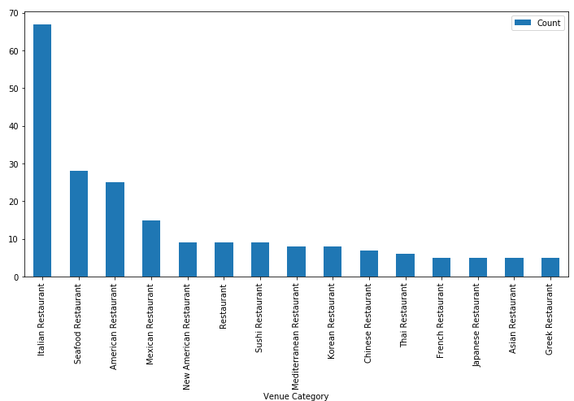

The bar graph below shows the number of Italian restaurants in each neighborhood. North End is an outlier with over 40 restaurants. I will remove this from the dataset as I will not plan to open up any restaurant in an overcrowded area.

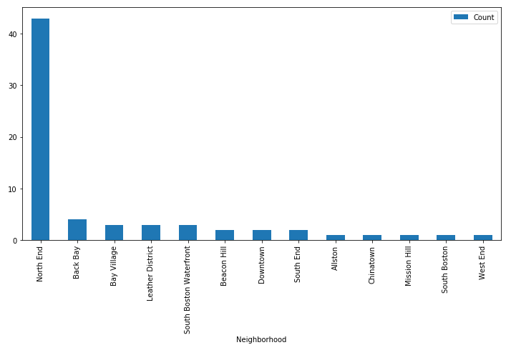

K-Means clustering was my choice of unsupervised algorithm. I used Number of Likes, number of restaurants in the neighborhood, number of Italian Restaurants in the neighborhood as my attributes to create clusters for the restaurants. Using this algorithm, I can easily see the restaurants that are together based on number likes and number of restaurants relative to their neighborhood.

**Results**

Based on the results below, Back Bay and Bay Village looks to be the hot spots for the most likes. The only Tier 1 cluster is found in Bay Village. Back Bay has 3 Tier 2 cluster restaurants.

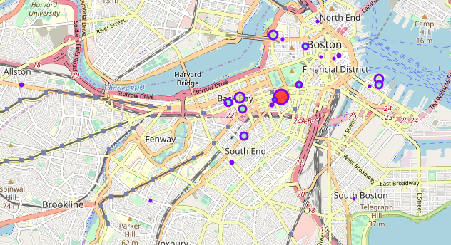

**Conclusion**

Based on the results above, I come to the conclusion to recommend to start a restaurant in Back Bay. Back Bay only has an Italian Restaurant to Total Restaurant ratio of .15. This is really low as there are currently 26 restaurants in the area, but only 4 are Italian. So, there is definitely room for more Italian Restaurants in these areas. Looking at the likes, Back Bay has 3 Italian Restaurants in the 2nd best cluster and the last restaurant in the 3rd best cluster. This means these restaurants have received a lot of likes compared to other Italian Restaurants in other areas.

Although Bay Village has the only restaurant in the best cluster, this seems to be an outlier. Bay Village's 2 other restaurants are in the worst cluster and 3 best/2 worst cluster. So it seems it is not that easy to open an Italian Restaurant here. Also, 3 out of the 12 restaurants are Italian. This is much more crowded than Back Bay's 4 Italian Restaurants to 26 total restaurants.